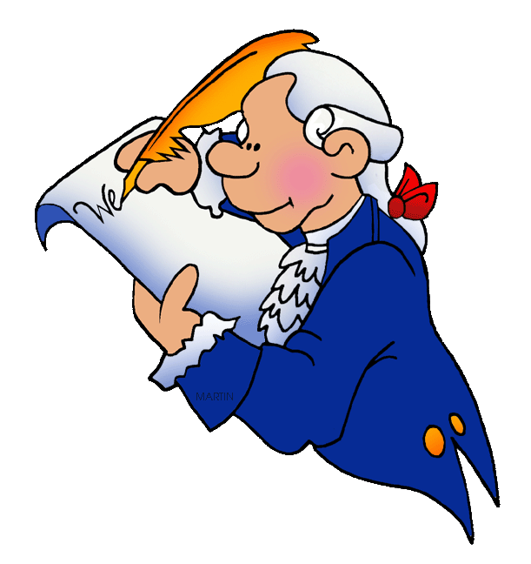
2019 First Quarter Civics Standards:

SS.7.C.1.1: Recognize how Enlightenment ideas including Montesquieu’s view of separation of power of John Locke’s theories related to natural law and how Locke’s social contract influenced the Founding Fathers.
Words to know: | Explanation
Enlightenment –  Montesquieu  Locke  (SS.7.C.1.1) | Enlightenment-period of time when people started questioning the government  Montesquieu – divided government into parts (separation of powers) with each part being equal or balanced with the other parts through limits on the other parts (branches) of government (checks and balances)  Locke - Humans are born with basic rights of life, liberty, property, and the freedom to find happiness, social contract is when people give power/rights to government in exchange for protection-if the government fails to do their part, the people can abolish the government
SS.7.C.1.2: Trace the impact that the Magna Carta, English Bill of Rights, Mayflower Compact, and Thomas Paine’s “Common Sense” had on colonists’ views of government.
Words to know: | Explanation
Magna Carta  (SS.7.C.1.2) | Limited the power of the king and protected certain rights for the nobles. It introduced rule of law (no one is above the law), limited government (power of the government is limited by the constitution and each branch is limited in what it can do), and due process (right to fair and reasonable rules and treat all people in the same way.)
English Bill of Rights  (SS.7.C.1.2) | Expanded the power of the English Parliament and expanded the rights of the people, as well as further limiting the power of the king.  - Right to bear arms  - Petition the government  - Fair trial  - No excessive bail or fines or cruel and unusual punishment.
Mayflower Compact  (SS.7.C.1.2) | Started self-government, men created a new government and agreed to follow its rules, in exchange they would protect each other.
Thomas Paine’s  Common Sense  (SS.7.C.1.2) | Paine explained arguments for independence in a way that was easy for everyday colonists to understand. He encouraged them to support the fight for independence.

SS.7.C.1.3: Describe how English policies and responses to colonial concerns led to the writing of the Declaration of Independence.
Words to know: | Explanation
Events leading to the Declaration of Independence  (SS.7.C.1.3) | Olive Branch Petition – violations of our rights, object to absolute tyranny, was not received by the king  Declaration of Independence – taxation without representation(Stamp Act), British were too controlling-limiting growth of colonies, creating multitude of the new offices, violating due process rights, limited trade, Quartering Act, Boston Tea Party, Boston Massacre
S.7.C.1.4: Analyze the ideas (natural rights, role of the government) and complaints set forth in the Declaration of Independence.
Words to know: | Explanation
Natural Rights and the role of government  (SS.7.C.1.4)  Declaration of Independence | Humans are born with basic rights of life, liberty, property, and the freedom to find happiness. It is the government’s role to protect these rights. Under the idea of social contract, citizens give up some freedom in exchange for government protection of rights. If the government does not protect the citizens’ rights, they have the right to overthrow the government.  Purpose of Declaration was to create a government to secure the rights of the people
SS.7.C.1.5: Identify how the weaknesses of the Article of Confederation led to the writing of the Constitution.
Words to know: | Explanation
Weaknesses of the Articles of Confederation  (SS.7.C.1.5) | Weak central government, congress did not have the power to enforce laws, only one branch, central government had no power to collect taxes to support military, every state had to support changes to the Constitution, central government had no power to put down rebellions like Shay’s Rebellion.
SS.7.1.6 Interpret the Intentions of the Preamble of the Constitution.
Words to know: | Explanation
Preamble  We the People  In order to form a more perfect union  Establish justice  Ensure domestic tranquility  Provide for the common defence  Promote the general welfare  Secure the blessings of liberty to ourselves and our posterity  Do ordain and establish | Introduction to the US Constitution  Speaking for All of the people of the United States together  TO make a better nation-creating their own self-government  Create a justice system to make sure things are fair  Make sure we live in a peace-filled country  Create a military AND be able to pay for it  Let the people’s voices be heard  Make our nation free for us and for future generations  Make legal, put into action
SS.7.C.1.7: Describe how the Constitution limits the powers of government through separation of powers and checks and balances.
Words to know: | Explanation
Power limits –  Separation of power  (SS.7.C.1.7) | Power is not held in one place, divided among the three branches.
Power limits –  Checks and balances  (SS.7.C.1.7) | Power is checked in each branch by the other two branches.
SS.7.C.1.8: Explain the viewpoints of the Federalists and the Anti-Federalists regarding the ratification of the Constitution and inclusion of a bill of rights.
Words to know: | Explanation
Views of Federalists  (SS.7.C.1.8) | Supported ratification of the Constitution.  Wanted a strong central government, because a central government could represent the nation to other countries, best protect citizen’s rights, thought it would not be too powerful because of the three branches.
Views of Antifederalists  (SS.7.C.1.8) | Did not support ratification of the Constitution.  Wanted a small central government like that provided in the Articles of Confederation, because state gov’t could better take care of local needs. Opposed limiting the power of the states.  Wanted a Bill of Rights to protect citizen’s rights.
Ratify | To pass or approve
SS.7.C.1.9: Define the rule of law and recognize its influence on the American legal, political, and governmental system.
Words to know: | Explanation
Rule of Law – how it influences the development of our government(SS.7.C.1.9) | Laws apply equally to all, no one is above the law.

SS.7.C.3.1: Compare different forms of government (direct democracy, representative democracy, socialism, communism, monarchy, oligarchy, autocracy).
Words to know: | Explanation
Direct democracy  (SS.7.C.3.1) | Government where citizens participate directly in lawmaking process and day to day work of governing the country.
Representative democracy  (SS.7.C.3.1) | Government where citizens elect leaders to represent their rights and interests in government. The elected representatives do the day to day work of governing the country.
Socialism  (SS.7.C.3.1) | a way of organizing a society in which major industries are owned and controlled by the government rather than by individual people and companies
Communism  (SS.7.C.3.1) | a way of organizing a society in which the government owns the things that are used to make and transport products (such as land, oil, factories, ships, etc.) and there is no privately owned property
Monarchy  (SS.7.C.3.1) | A king or queen (monarch) rules the country. Power is inherited from the family line. Monarchs held all of the power and final say in the government. Modern monarchs usually share power.
Oligarchy  (SS.7.C.3.1) | A small group of people have all the power. Junta – a small group of military leaders rule by taking over by force, operates like a dictatorship.
Autocracy  (SS.7.C.3.1) | One person is in charge and holds all the power.
Dictatorship  (SS.7.C.3.1) | A government where there is a single ruler who holds all of the power and makes all of the decisions. This person typically rules by force through fear.

SS.7.C.3.2: Compare parliamentary, federal, confederal, and unitary systems of government.
Words to know: | Explanation
Parliamentary government  (SS.7.C.3.2) | Elected members of parliament choose the prime minister. The prime minister is the head of the executive branch and the leader of the legislature (parliament).
Federal government  (SS.7.C.3.2) | A type of government in which power is shared between a national (federal) government and smaller regional governments (states) within a nation.
Confederal government  (SS.7.C.3.2) | A system of government in which independent states form a weak central government
Unitary government  (SS.7.C.3.2) | A government in which the constitution concentrates all power with the national or central government.

